**Docker and Kubernetes 201 Project Execution Steps:**

1.I am using AWS clod deployment application below screen shot EC2 instance .

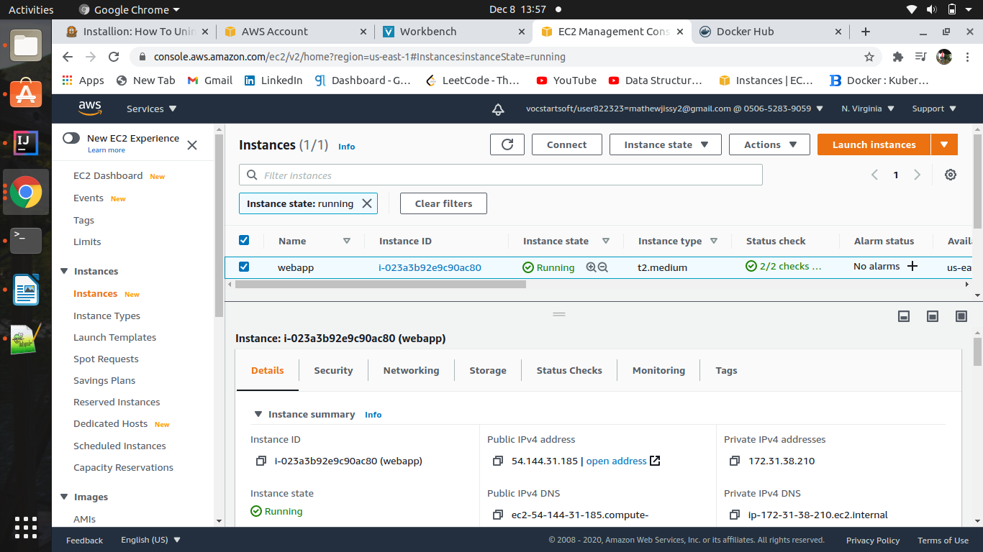

2. After created EC2 instance need to install docker ,kubectl and minikube

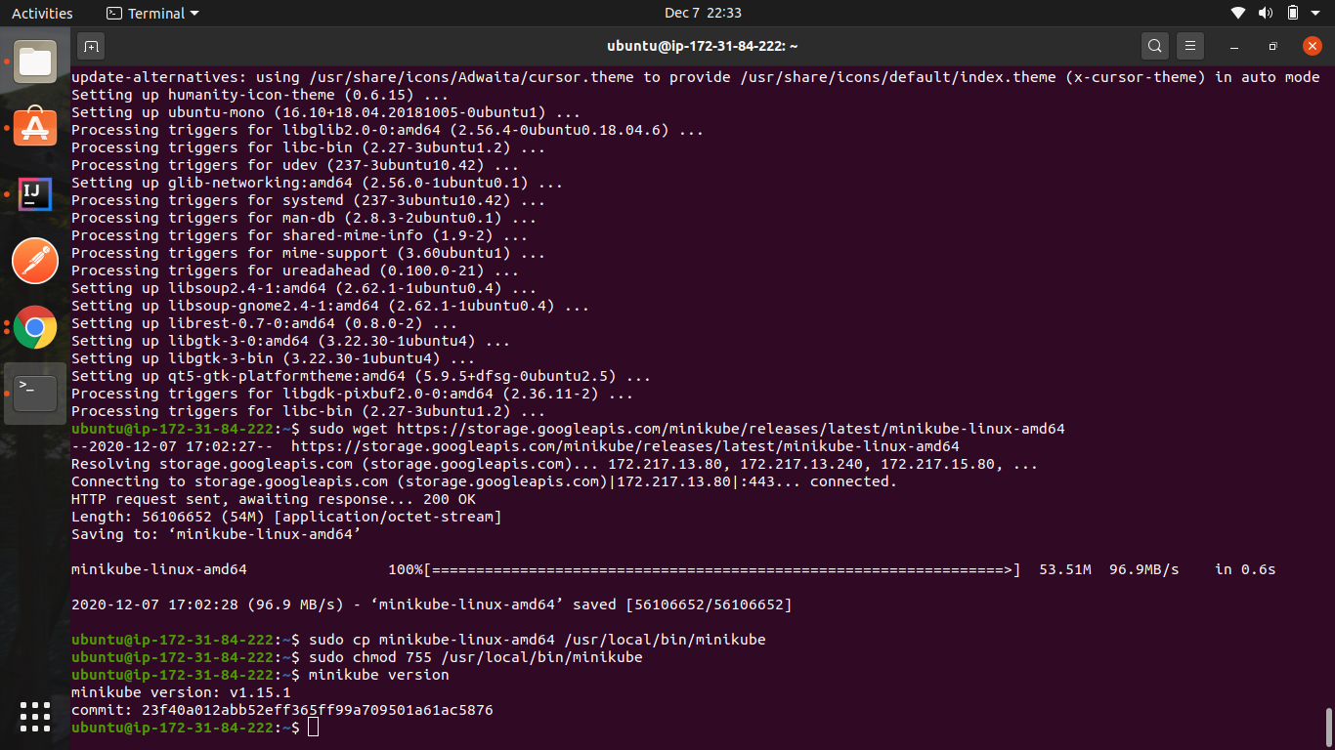

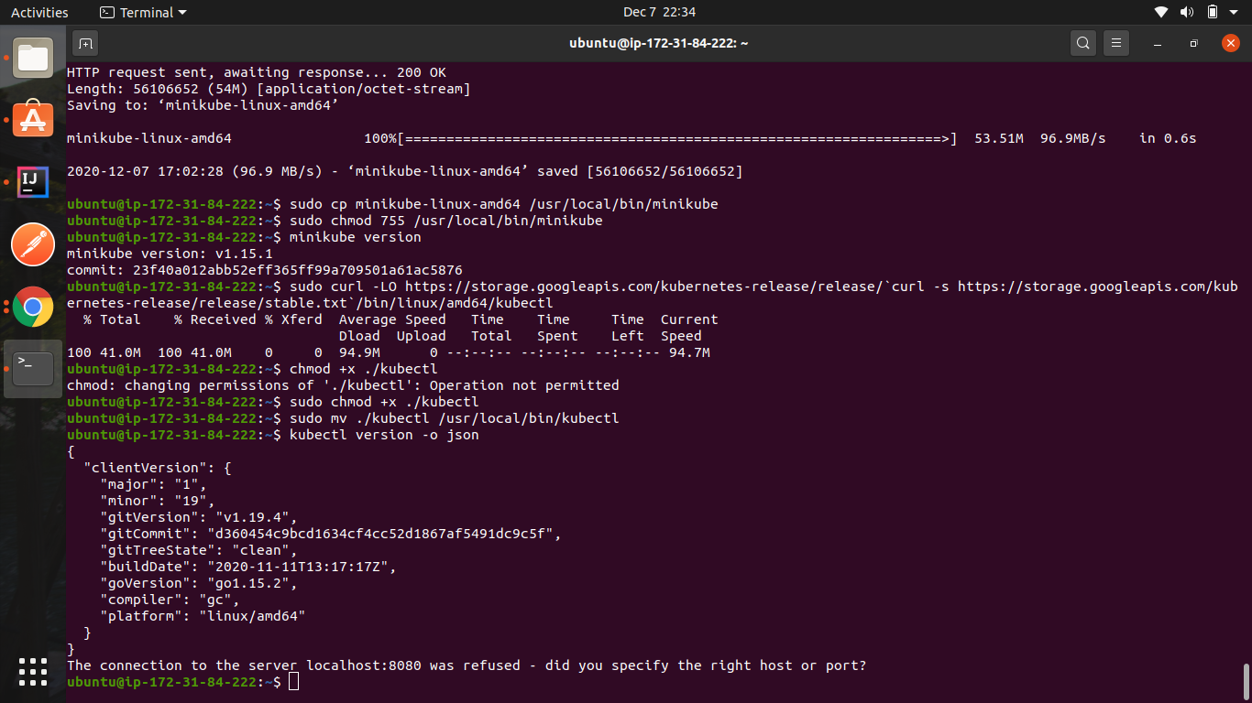

3. Go to the folder created and create a Docker file to define the steps for Docker

touch Dockerfile -- create Dockerfile

vi Dockerfile -- open Dockerfile

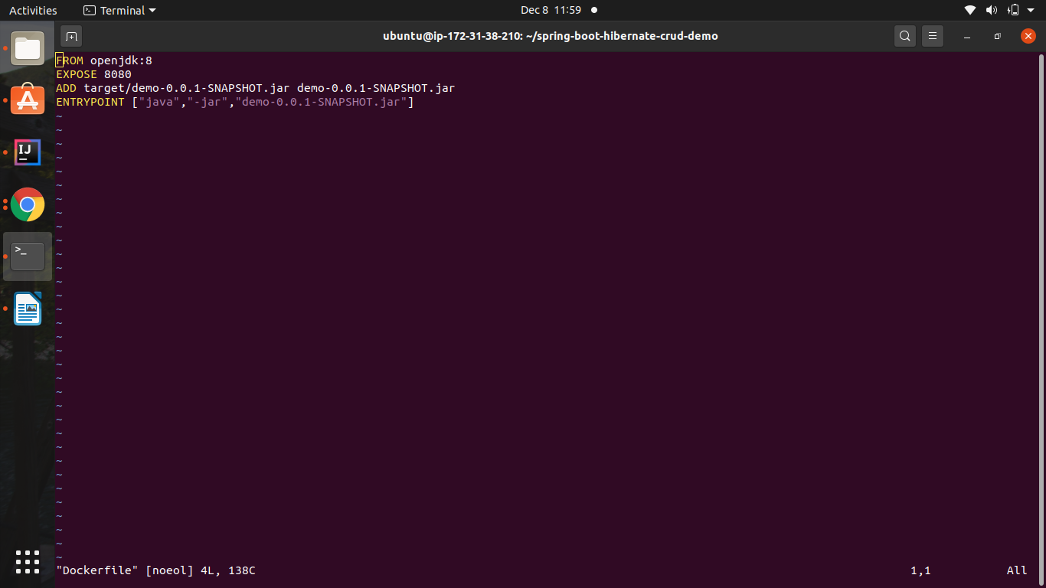

Below are the details of commands used:

* FROM Maven:slim -> to pull the latest version of Maven from repository
* RUN mkdir –p /Mindtree/app/src ->create directory provide the working directory
* COPY src /Mindtree/app/src -> copy file.
* RUN MVN –f /Mindtree/app/pom.xml clean package:Will generate jar file with maven command
* RUN openjdk:8-jdk-alpine -> to install jdk
* Expose -> expose tomcat to mentioned port
* RUN cp location location -> copy project to tomcat webapp folder

4. Now its time to build the docker file to generate the docker image, using below command

dokcer build –f Dockerfile -t springboot-crud .

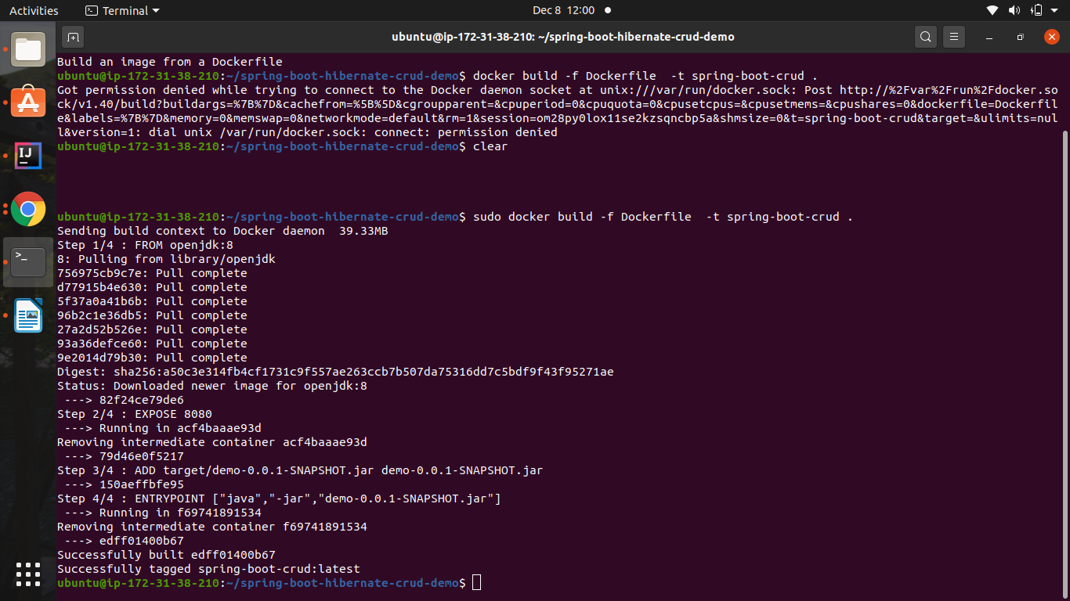

5. Docker file has been built successfully, We can view the docker images created using below command

docker images

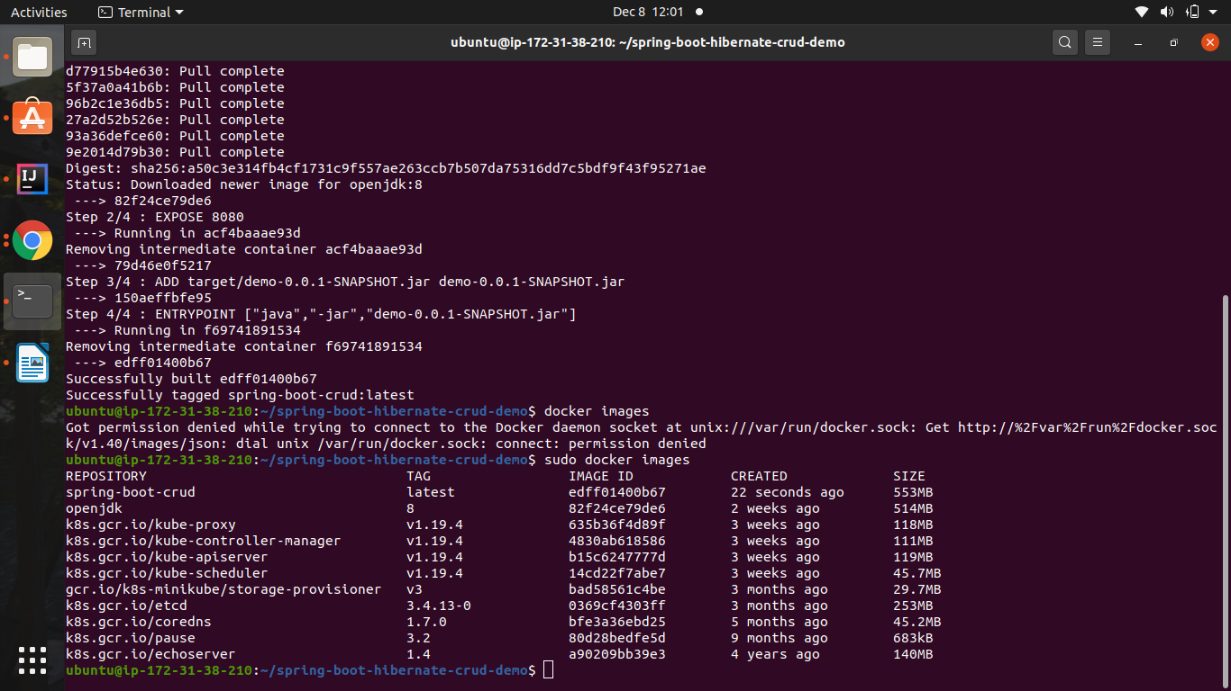

6. Once docker image is created, we have to run the generated docker image using below command

docker run -p 8080:8080 springboot-crud

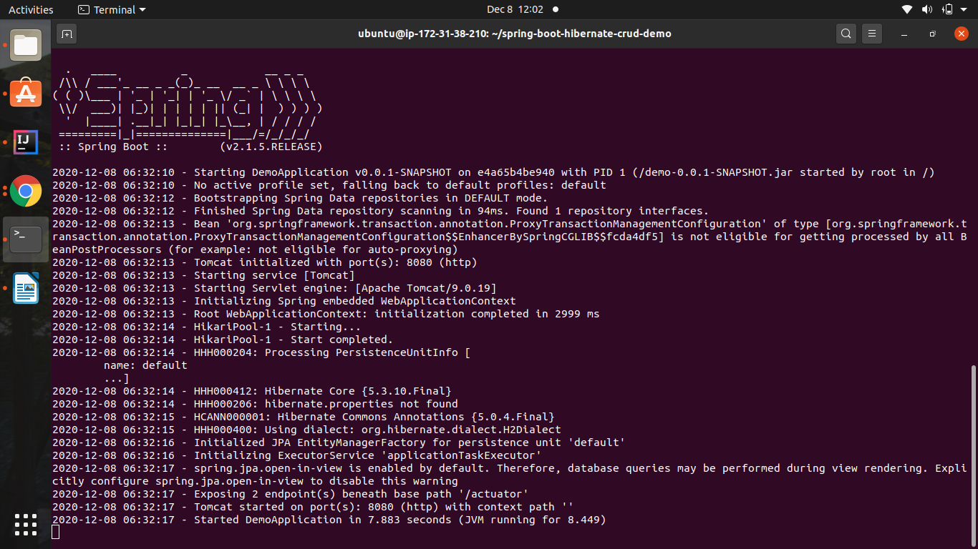

7. After docker run is success, we have to push this image to docker hub- we should have created the docker hub account in

<https://hub.docker.com> – user name is **vinaydocker15**

8. Login to the docker hub account from our linux terminal – using below command

docker login

enter the username and pwd – (of hub account)

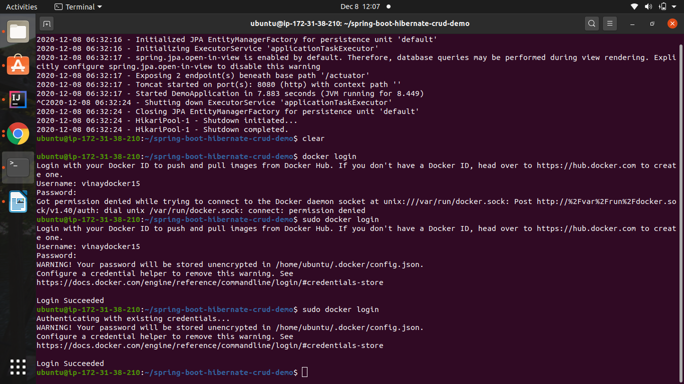

9. . Tab the image built, using below command

docker tag docker-traning vinaydocker15/docker201images

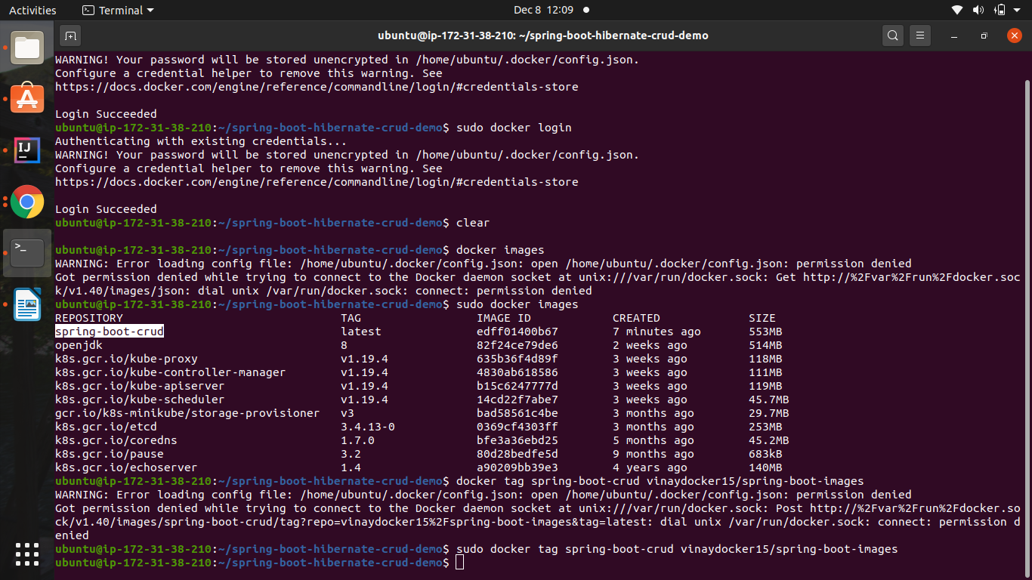

10. Now we can push our image to docker hub using below command

docker push vinaydocker15/ docker201images

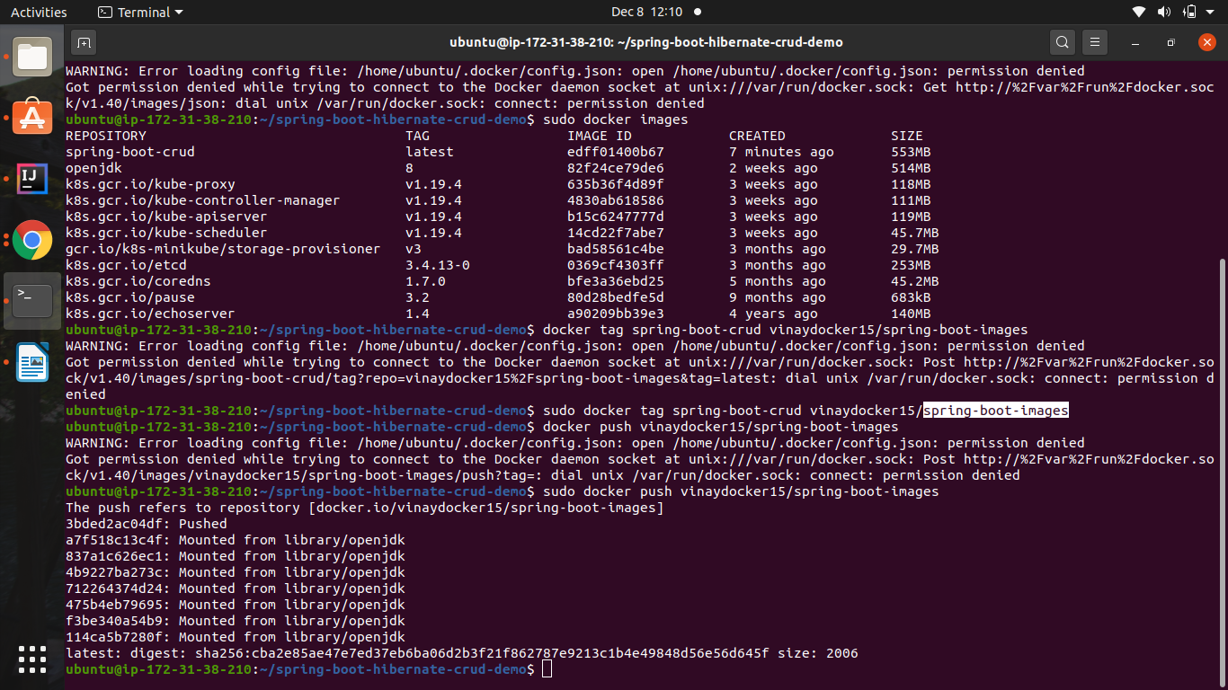

11. Docker image has been pushed successfully to docker hub, to verify the same, login to docker hub account from browser

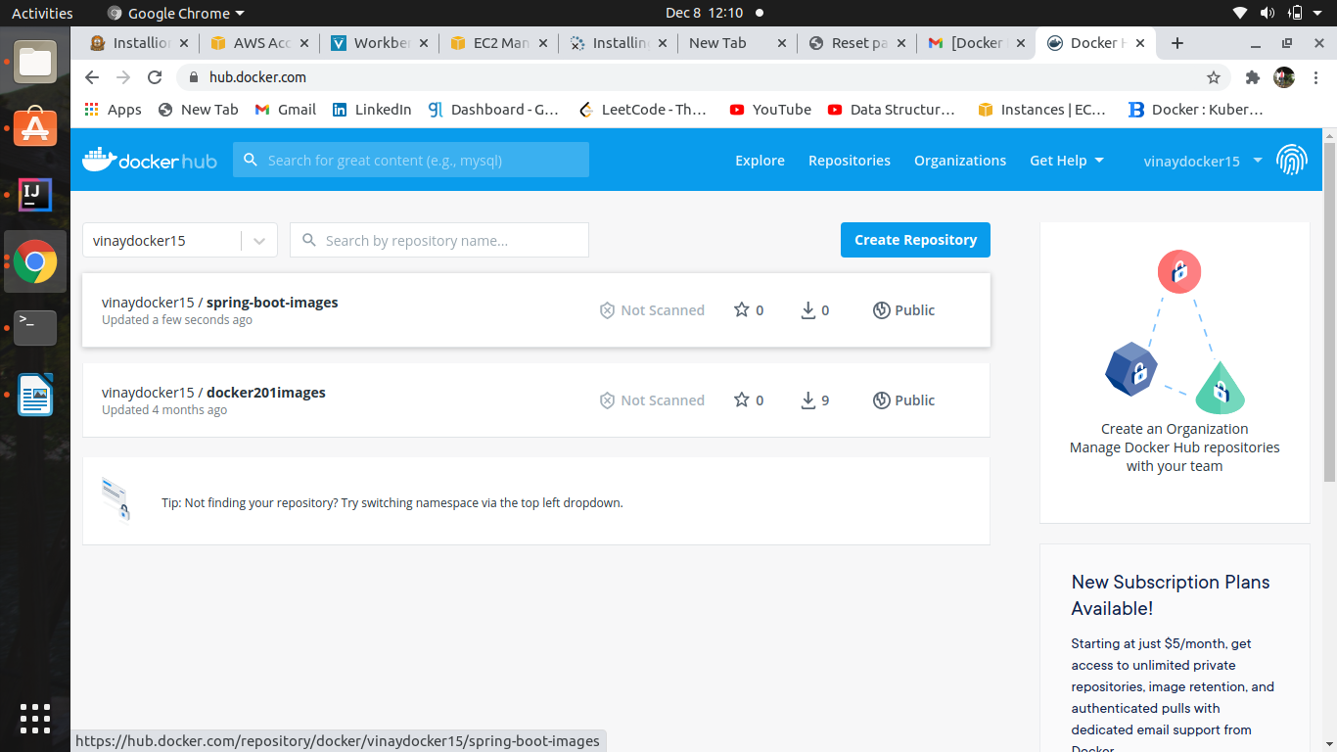

12.Now We have write deployment.yml and service .yml below command excute yml file .

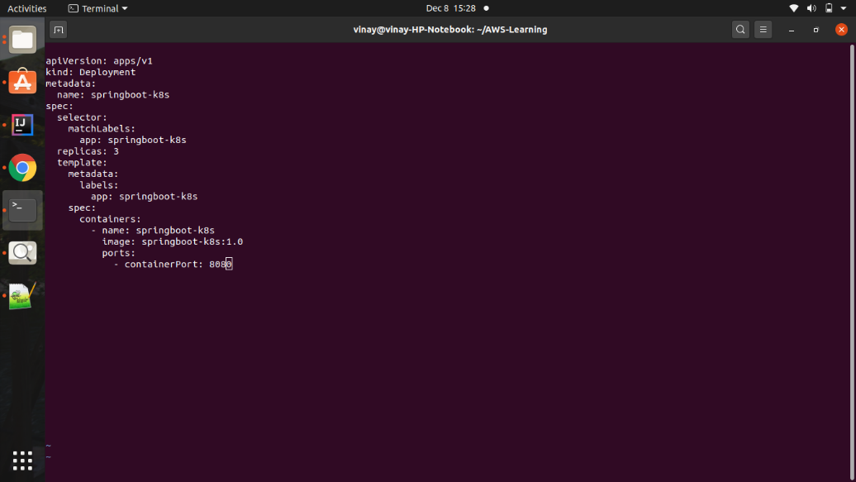

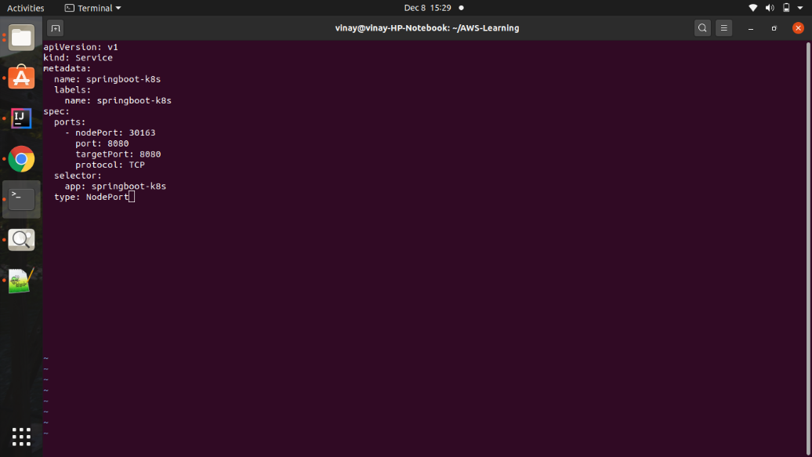

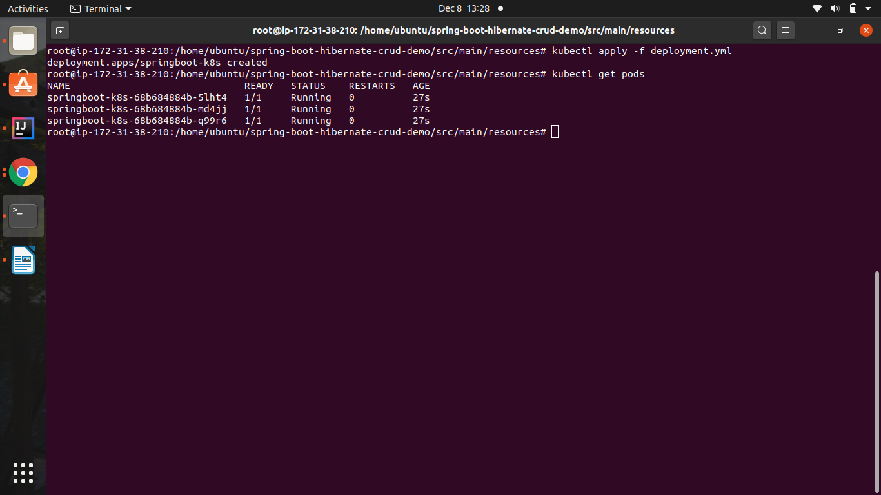

13.service .xml

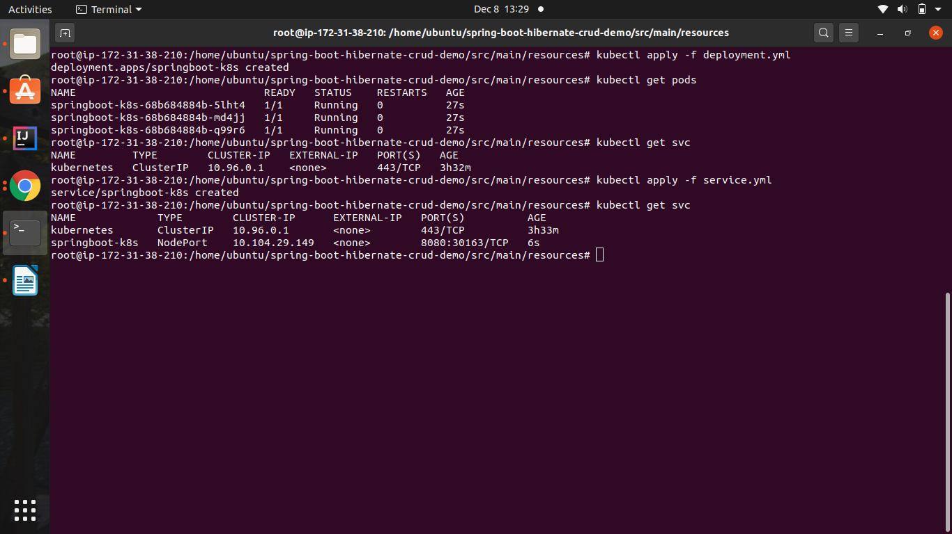

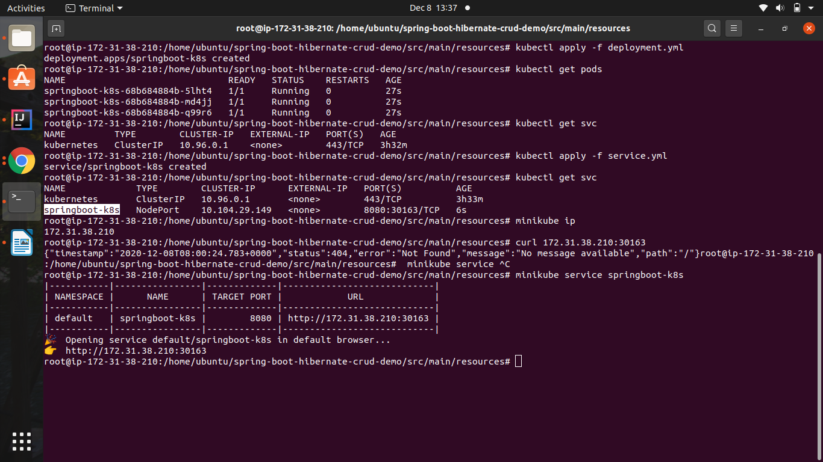

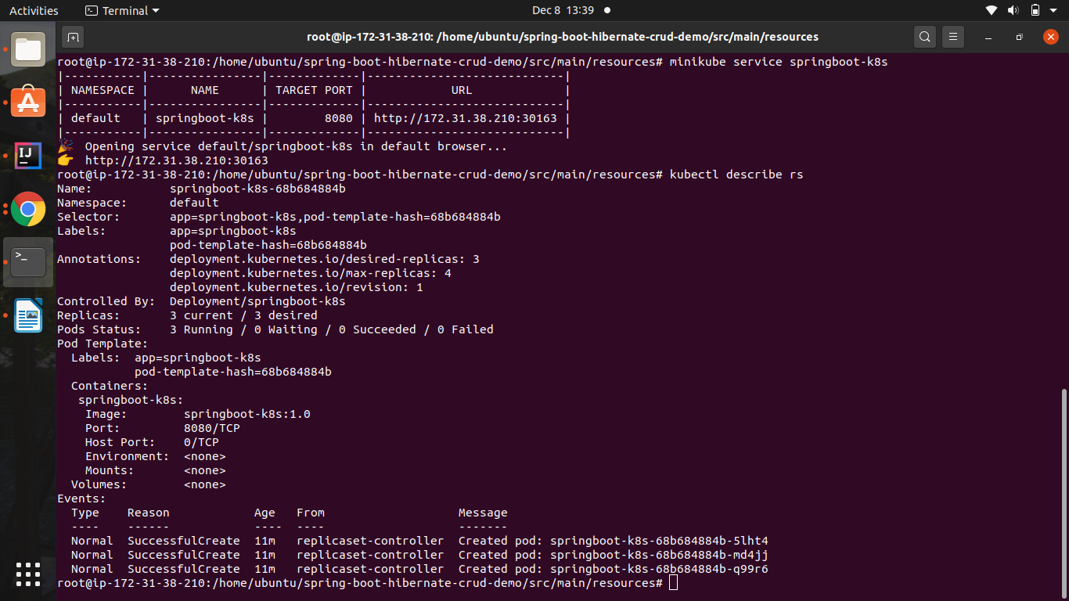

Now Application is up

